Trig in a right angled triangle
(Exam level questions using Sohcahtoa and Pythagoras)
[Answers at the end of this unit]
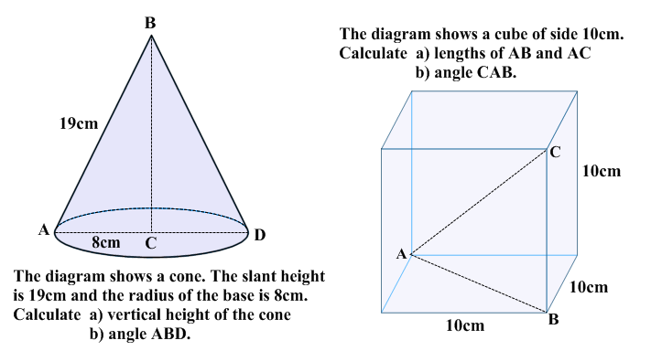

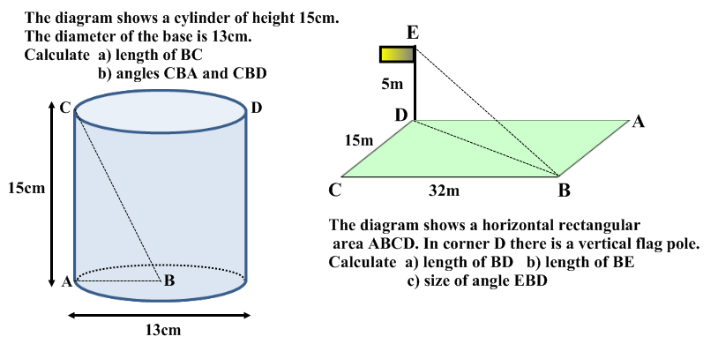

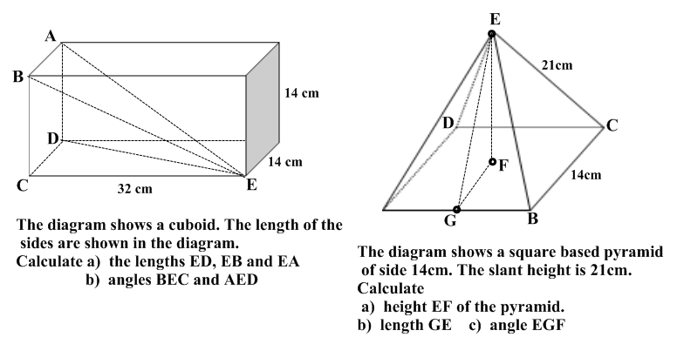
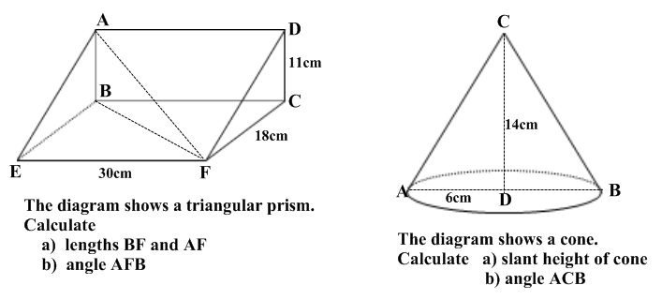
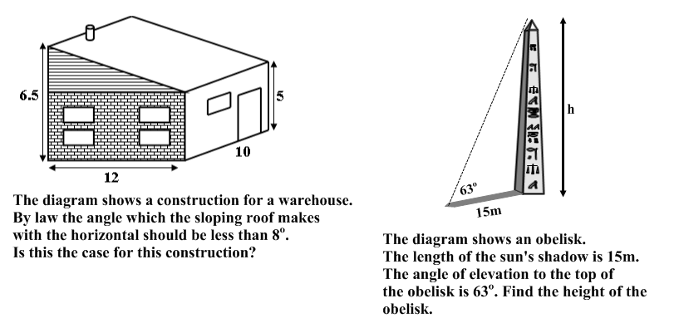
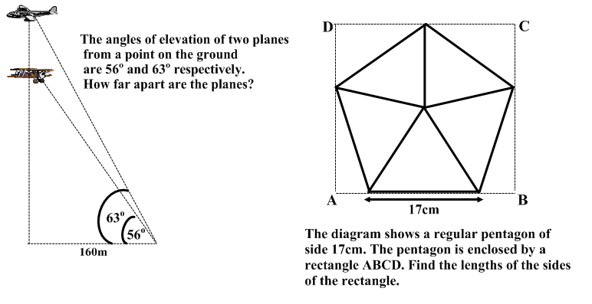

Answers

Q1. (a) 17.2cm (b) 49.8º | Q2. (a) AB = 14.1 AC = 17.3  (b) ABD = 35.3 º | Q3.(a) 16.3cm (b) CBA = 66.6 º,  CBD = 46.8 º
Q4. (a) 35.3m (b) 35.7m  (c) 8º | Q5. (a) ED = 34.9 EB = 34.9 EA = 37.6 (b) 23.6 º , 21.9 º | Q6. (a) h = 18.5 (b) 19.8 (c) 69 º
Q7. (a) BF = 35.0, AF = 36.7  (c) 17.4 º | Q8. (a) 15.8 (b) 46.4 º | Q9. 7.1 º is acceptable
Q10. Height = 29.4 | Q11. 76.8 m | Q12. 26.2 cm by 27.6cm

